Responsive Design with Bootstrap

Boostrap is a responsive CSS framework which allows for “responsive design.”

Responsive design makes it so that websites automatically conform to different screen specs. You do not have to build a PC version of your website, then mobile, this way.

Bootstrap is added to a website via the following code:

<link rel="stylesheet" href="//maxcdn.bootstrapcdn.com/bootstrap/3.3.1/css/bootstrap.min.css"/>

# Examples

## Preparing HTML for Bootstrap

Set div class as container-fluid. This makes sure that all content on the page is mobile responsive when you set your all-encompassing div’s class with it.

<div class=”container-fluid”>

Div is used to “group” elements. This is useful for getting multiple elements on the same line, or for using Bootstrap’s grid setup.

<div class="row"> to create row.

Each element in the row in the Div needs its own divs.

## Button Classes

Bootstrap comes with several pre-defined colors for buttons.

### Btn-block

Makes button span 100% of available width.

<button class="btn btn-block">Info</button>

### Btn-primary

Main color in app, which is a Facebook blue.

<button class="btn btn-block btn-primary">Facebook Like</button>

### Btn-info

Calls attention to optional actions a user can take; is Twitter blue.

<button class="btn btn-block btn-info">Twitter Tweet</button>

### Btn-danger

Notify users that the button performs a destructive action; is Google Plus/Pinterest red.

<button class="btn btn-block btn-danger">Pinterest Pin</button>

## Bootstrap button grid classes

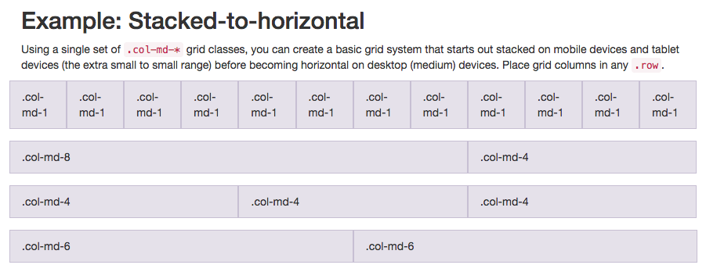

Note: md means medium and * is a number specifying how many columns wide the element should be. Aka, column width of an element is a medium-sized screen.

Xs means extra small.

How to setup grid:

<div class="row">

<div class="col-xs-4"><button class="btn btn-block btn-primary">Like</button></div>

<div class="col-xs-4"><button class="btn btn-block btn-info">Info</button></div>

<div class="col-xs-4"><button class="btn btn-block btn-danger">Delete</button></div>

</div>

## Spans for Inline Elements

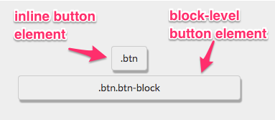

By using the **span** element, you can put several elements together, and even style different parts of the same element differently.

<p>Things cats <**span** class="text-danger">love:</span></p>

## Div Two Elements in One Row (custom heading)



<div class="row">

<div class="col-xs-8"><h2 class="text-primary text-center">CatPhotoApp</h2></div>

<div class="col-xs-4"><a href="#"><img class="img-responsive thick-green-border" src="https://bit.ly/fcc-relaxing-cat" alt="A cute orange cat lying on its back. "></a></div>

</div>

## Font Awesome

Add the following code to top of HTML document:

<link rel="stylesheet" href="//maxcdn.bootstrapcdn.com/font-awesome/4.5.0/css/font-awesome.min.css"/>

Lower case “i” element is used for icons.

<i class="fa fa-info-circle"></i>

Or, nested within an element:

<button class="btn btn-block btn-primary**"**>**<i class="fa fa-thumbs-up"></i>** Like</button>

**Fa-thumbs-up:** Thumbs Up icon.

**Fa-info-circle:** Information icon.

**Fa-trash:** Trashcan icon.

**Fa-paper-plane:** Paper plane icon.



## Responsively Style Radio Buttons and Checkboxes

### Radio buttons:

<div class="row">

<div class="col-xs-6"><label><input type="radio" name="indoor-outdoor"> Indoor</label></div>

<div class="col-xs-6"><label><input type="radio" name="indoor-outdoor"> Outdoor</label></div>

</div>

### Checkboxes

<div class="row">

<div class="col-xs-4"><label><input type="checkbox" name="personality"> Loving</label></div>

<div class="col-xs-4"><label><input type="checkbox" name="personality"> Lazy</label></div>

<div class="col-xs-4"><label><input type="checkbox" name="personality"> Crazy</label></div>

</div>

You can give ids to elements not only as a means to refer them to their CSS. These Ids can also be used in conjunction with jQuery, wherein it seeks the element ids. We want jQuery to target each button by its unique id.

# FreeCodeCamp sample:

<!--Only change code above this line-->

<div class="container-fluid">

<h3 class="text-primary text-center">jQuery Playground</h3>

<div class="row">

<div class="col-xs-6">

<h4>#left-well</h4>

<div class="well" id="left-well">

<button class="btn btn-default target" id="target1">#target1</button>

<button class="btn btn-default target" id="target2">#target2</button>

<button class="btn btn-default target" id="target3">#target3</button>

</div>

</div>

<div class="col-xs-6">

<h4>#right-well</h4>

<div class="well" id="right-well">

<button class="btn btn-default target" id="target4">#target4</button>

<button class="btn btn-default target" id="target5">#target5</button>

<button class="btn btn-default target" id="target6">#target6</button>

</div>

</div>

</div>

</div>

# Definitions

Text-primary: Sets the text to the app’s primary color.

Text-center: Centers the text.

Btn class: Uses Bootstrap button style over HTML’s.

Btn-default: Creates a white button instead of grey of btn.

Div class well: Gives visual depth to the columns its applied to.